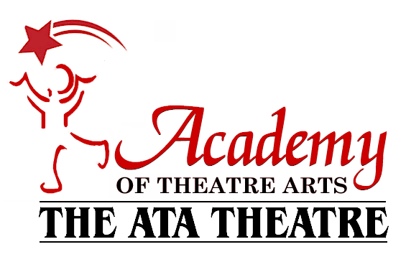

ATA PERFORMER’S HANDBOOK

Please read carefully. Sign and return the bottom portion on page 2 on the first day of classes.

Payment Policies:

Payment is due by the 1st of the month. If payment is not received by the 5th, a $10 late fee will be added to your account.

I understand if my payments are not up to date before each show, my child will not receive their costume until all payments have been made.

I understand if my child chooses to leave the school for any reason, tuition will not be reimbursed after the 1st of the month.

I understand if my check is returned from the bank, the $15 return fee will be added to my account.

Payment is based on a 9-month payment schedule (Sept.-May). Extra rehearsals and breaks have been put into this price. Each monthly payment is the same.

The production fee of $60 for each of the January Showcase (due in November) & May Showcase (due in March) is not included in my monthly tuition. This fee is due on the first of that month with your normal tuition payment.

If your credit card is on file, payment will go through on the 1st of the month. If you are paying by check or cash an email bill will be sent to your email on file two weeks prior to the due date. This email is sent through our Quickbooks system.

If you require a mailed bill or receipt each month with credit card, please email erinzimmerman@academyoftheatrearts.com.

Class Policies:

The dress rehearsal days are as follows; Saturday, January 14th & Saturday, May 13th. (Specific times will be given two months prior to the date. These dates & times are mandatory.)

Costumes will be given to your child on the dress rehearsal date.

If you have a conflict with a January Showcase date please email erinzimmerman@academyoftheatrearts.com by October 1st but we cannot guarantee to accommodate all conflicts.

If your child’s class is cancelled due to weather or other extenuating circumstances, a make-up date will be emailed to families. ATA holds make-up dates on a Saturday. This date will be emailed the day after class has been cancelled.

If you would like to receive text updates for cancellations please fill out the form below.

Other Information:
Closing Policy:
ATA closes due to weather when Williamsville Schools are closed and/or afternoon activities are cancelled. We will make a decision by 2:00pm, at this time all families will receive an email, text update if you choose, and all information will be posted on our social media.

Class Attire:
Fundamentals of Musical Theatre 5&6/ 7&8- Comfortable clothing. Dance shoes are not required.
Acting for Live Theatre & Voice Performance-Comfortable clothing please no skirts or dresses
Jazz for Musical Theatre- Black jazz shoes, shorts, leggings, or loose fitting pants. Absolutely no jeans, skirts or dresses. Please make sure hair is pulled back off the face.

Parking: You may use any of the parking available in the Transitowne Plaza. Before and after class, DO NOT line up cars in front of our doors as there are other businesses still open during these times.

----------------------------------------------------------------------------------------------------------

By signing this agreement, I will adhere to the policies and guidelines listed above.

Print your name here___________________________________

Parent Signature________________________ Date_________

I would like to be alerted via text message of ATA Closings due to weather.

Cell Phone Number:________________ Cell Phone Provider:____________

ATA Performance Dates & Information:
*More information on show dates and times will be available 2-3 months prior to show date

Reading, Rocking & Arithmetic
January Showcase
Friday, January 20th, Saturday, January 21st & Sunday, January 22nd

Best of Broadway
May Showcase
Friday, May 19th, Saturday, May 20th & Sunday, May 21st

Important Contact Information:

ATA Phone Number: 716-810-0551

ATA Email Address: info@academyoftheatrearts.com

Erin Email Address: erinzimmerman@academyoftheatrearts.com

Lauren Email Address: laurenbaker@academyoftheatrearts.com

-Website has current calendars and ticket information www.academyoftheatrearts.com

* Please refer to the ATA Calendar for specific ATA closing and other information. This calendar is available on our website.

